

**SSR COLLEGE OF ARTS, COMMERCE & SCIENCE**

**SILVASSA**

**(Affiliated to Savitribai Phule Pune University, NAAC Accredited with B+ Grade)**

**Submitted to the partial fulfillment of**

# S.Y BBA(CA)

2021-2022

Project Work

## SSR COLLEGE MANAGEMENT SYSTEM

Guided By: Submitted By:

Mr.Vishal Iangaliya Singh Souravdeep Durgesh

Gupta Rajnandini Jayprakash



**SSR COLLEGE OF ARTS, COMMERCE & SCIENCE**

**SILVASSA**

**(Affiliated to Savitribai Phule Pune University, NAAC Accredited with B+ Grade)**

**Sayli, Silvassa-396230, D&N.H**

Department of Computer Application

# **CERTIFICATE**

This is to certify that Mr. **Souravdeep singh and Ms.Rajnandini Gupta** of S.Y.B.B.A [Computer Application] has successfully completed his/her project work on

the topic **SSR COLLEGE MANAGEMENT SYSTEM** in the academic year

2020-2021.

**Project Guide H.O.D**

**Internal Examiner External Examiner**

**Seal of the College**

**ACKNOWLEDGEMENT**

It is a great pleasure to acknowledge and express our deep sense of gratitude to **SSR College of ARTS COMMERCE & SCIENCE** for providing me the infrastructure to carry out the project.

I extremely grateful and remain indebted to our guide and HOD, for being a source of inspiration and for his constant support in the Design, Implementation and Evaluation of the project. I am thankful to him, for his constant constructive criticism and valuable suggestions, which benefited me a lot while developing the project on **SSR COLLEGE MANAGEMENT**

**SYSTEM**. He has been a constant source of inspiration and motivation which helped us to complete this project successfully.

I also extend my gratitude to our teachers and other staff members of the department for their constant support for completing this project.

I would like to thank Savitribai Phule Pune University for providing us an opportunity to apply our knowledge and skills in a practical environment as a part of curriculum for **S.Y.B.B.A [Computer Application].**

Lastly but significantly, we express sincere gratitude to all our friends and fellow students at SSR College for their help and timely advice on various occasions during this project.

## ABSTRACT

The project titled **“SSR COLLEGE MANAGEMENT SYSTEM”**

is designed with HTML,CSS, as front end and MYSQL,PHP,JAVASCRIPT as back end.

This system is implemented to reduce the manual work and enhances the accuracy of work , especially made for the **Student for inquiry.** This system manages and maintains the records of Student and their personal detail. This desktop application has been made in a user friendly interface. So that the admin can add and delete food items easily.

The system is totally built at Client side so that student can go throught the system .This project report documents the process of designing and developing a desktop application to be used in a café. The design form and the data report screenshots, advantages and limitations data dictionary, and future enhancement have been included.

# INDEX

|  |  |  |  |
| --- | --- | --- | --- |
| **S.NO.** |  | **TOPIC** | **PAGE.NO** |
| **1.** |  | **INTRODUCTION**  1.Introduction to System  2.Scope Of The System | **-06** |
| 2. | 1. 2. | **TOOL INFORMATION**  Front End Tool  Back End Tool | **- 08** |
| **3.** |  | **ANALYSIS**   1. Feasibility Study 2. Fact Finding Technique | **- 10** |
| **4.** |  | **SOFTWARE AND HARDWARE REQUIREMENT** | **-13** |
| **5.** |  | **SYSTEM DESIGN**   1. DFD 2. DATA DICTIONARY | **-14** |
| 6. |  | **INPUT AND OUPUT DESIGN**  1.Screenshots | **-18** |
| **7.** |  | **FUTURE ENHANCEMENT** | **-25** |
| **8.** |  | **BIBLIOGRAPHY** | **-26-27** |

**1. INTRODUCTION**

**1.1 INTRODUCTION TO SYSTEM**

“SSR COLLEGE MANAGEMENT SYSTEM” is a desktop application. This system is developed to automate day today activity of a student.

This system is developed to provide service facility to student. This student management system can be used by admin to handle the student informantion, their information and can help them easily find all about colleges. The services that are provided is college information like admission, courses, fee structure, college atmosphere etc.

Main objective to build the system is to give all the information about our college to the student and parents.

Student management system is the system for managing the Student records. The main point of developing this system is to help SSR College administrator manage the cstudent information and help the student for inquiry. In proposed system user can search for anything according to his choice, according to his/her needs.

The project has been developed because many student information have a lot difficulty to manage the information. By using manual method it is difficult to keep the correct student information and may be loss the student information.

The administrator can add or remove users and add or remove student informations, whereas the users can only access the client side website.

**1.2 SCOPE OF THE SYSTEM**

The application deals with creating a SSR College management system which will automate the major Student information such as address, keeping tracks of records of student information. Admin have the authority to control and modify the database. Scopes that have been considered during the development of the project are as follows:

1. User Friendly
2. Menu Driven Interface
3. Easily Upgradable
4. Data Retrieval, Updating, Insertion, Deletion
5. System Consistency
6. Allowing Keyboard Inputs
7. Taking care of Computing time 8. Easy Database Handling

## 

## 2.TOOL INFORMATION

### 2.1 FRONT END TOOL

HTML:-

The HyperText Markup Language or HTML is the standard markup language for document designed to be displayed in a web browser. It can be assisted by technologies such as cascading style sheet and scripting language such as Javascript.

CSS:-

Cascading style sheet is a style sheet language used for describing the presentation of a document written in a markup language such as HTML,CSS is a cornerstone technology of the world wide web,alongside HTML and Javascript.

## 2.2 BACK END TOOL

MYSQL:-

MYSQL is a open-source relational database management system.Its name is a combination of “My” the name of co-founder Michael Widenius’s daughter,and “SQL” the abbreviation for structured Query Language.

PHP:-

PHP is a general-purpose scripting language geared towards web development.It was originally created by Danish-Canadian programmer Rasmus Lerdorf in 1994. The Php reference implementation is now produced by the Php Group.

JAVASCRIPT:-

JAVASCRIPT,often abbreviation JS,is a programming language that is one of the core technologies of the world wide web,alongsideHTML and CSS. Over 97% of websites use javascript on the client side for web page behaviour,often incorporation third-party libraries.

## 3.ANALYSIS

### 3.1 FEASIBILITY STUDY

The objective of the feasibility study is to solve the problem and to acquire the ease of its scope. Feasibility means practicable. The feasibility analysis focuses on the fact that whether the project will be acceptable or not. If the feasibility analysis confirms that the project is feasible, it can be taken up for development. In preliminary investigation we found that project feasible.

#### Types of Feasibility

##### a.Operational Feasibility

Operational feasiblility makes a mark on whether the project can be done with full requirements that the clients provide or not. Includes following:

1. Analysing all requirements.
2. Can be done in given period of time or not.

##### b. Technical Feasibility

Technical feasibility takes into account the technical aspect of the project includes the following:

1. Whether the project can be implemented with the existing technology or not.
2. Whether the project technically compatible or not.

###### c. Economical Feasibility

It determines whether the requirement software is capable of generating financial gains for an organization. It involves the cost incurred on the software development team estimated cost of hardware and cost of performing feasibility study and so on. Studying the feasibility of the project, the project can be implemented with the given period of time and with the existing or specified technology. Hence, we can conclude that this project is feasible

#### 3.2 FACT FINDING TECHNIQUE

To study a system the analyst needs to do collect facts and all relevant information. The facts when expressed in quantitative form are termed as data. The success of any project is dependent upon the accuracy of available data. Accurate information can be collected with help of certain methods/techniques. These specific methods for finding information of the system are termed as fact finding technique Interview, Questionnaire, Record view and Observation are the different fact gathering techniques used by the analyst. The analyst may use more than one technique for investigation.

•**INTERVIEW :**

This method is used to collect the information from the groups of individuals. Analyst selects the people who are related with the system for the interview. In this method the analyst sits face to face with the people and records their responses. The interviewer must plan in advance the type of questions he/she is going to ask and should be ready to answer any type of questions. He should also choose a suitable place and time which will be comfortable for the respondent. The information collected is quite accurate and reliable as the interviewer can clear and cross check the doubts there itself. This method also helps gap the areas of misunderstandings and help to discuss about the future problems. Structured interview is more formal where fixed questions are asked, and specific information is collected whereas unstructured interview is more or less like a casual conversation where in depth areas topics are covered and other information apart from the topic may also be obtained

##### • RECORD VIEW

The information related to the system is published in the sources like newspapers, magazines, journals, documents, etc. This record review helps the analyst to get the valuable information about the system and the organization.

##### • OBSERVATION

Unlike the other fact gathering techniques, in this method the analyst himself visits the organization, he observes and understands the flow of the documents, working of the existing system, the users of the system etc. For this method to be adopted it takes an analyst to perform this job as he knows which points should be noticed and highlighted. The analyst may observe the unwanted things as well as simply cause delay in the development of the new system.

##### • QUESTIONNAIRES

Questionnaires are a research instrument that can be applied to fact finding in system development projects. It is an economical way of gathering data from large number of people.

### 4.SOFTWARE AND HARDWARE REQUIREMENTS

SOFTWARE REQUIREMENT Software used in the designing (code) of the system:

#### Operating system: Windows 10

**Application Softwares**: Visual Studio,HTML,CSS [Front-

End Tool] MYSQL,PHP,JAVASCRIPT [Back-End Tool]

#### HARDWARE REQUIREMENT

To run the application software of the system in the computer, the minimum hardware configuration required is as below:

* 1.7 GHz Pentium processor or other compatible
* Intel chipset motherboard
* 256 MB DDR-RAM
* Color Monitor or LCD
* Keyboard
* Mouse
* Printer

### 5. SYSTEM DESIGN

#### 5.1 DATA FLOW DIAGRAM

The data flow diagram are pictorial or graphical representation of the system study. The data flow covers all the processes and data storage area, which takes place during any transaction in the system. The data flow diagrams are functionally into context level, zero level diagrams.

1. **Process**: Here flow of data is transformed

1. **External Entity**: A source or destination of data, which is external to the system.

1. **A Data Flow**: It is a packet of data. It may be in the form of document, letter, etc

1. **Data storage**: Any storage of data but with no reference to
2. physical memory of storing.

**ZERO LEVEL DATA FLOW DIAGRAM**

**SSR COLLEGE**

**MANAGEMENT**

**SYSTEM**

**Admin Login**

**Student**

**Login**

Student

Addmission Form

### FIRST LEVEL DATA FLOW DIAGRAM

**User**

**Register**

**Login**

**Welcome user**

#### 

**5.2 DATA DICTIONARY**

Data dictionary is a repository that contains description of all the data objects consumed by the software. It is a list of names used by the system alphabetically. As well as the name, the dictionary should include a description of the named entity and, if the name represents of a composite object, there may be description of the name entity. Other information such as the date of creation, creator and the representation. Entity may also include depending on the type of module, which is being developed. The data dictionary software can check for name uniqueness and tell requirements analyst duplication. It serves as store of organizational information which can link analysis, design, implementation and evolution. As the system is developed, information is taken to inform the development. New information is added in it. All information about entity is in one place.

**DATA DICTIONARY :**

**TABLE :** Register User

|  |  |  |
| --- | --- | --- |
| **Field Name** | **Data Type** | **Description** |
| Username | Text | User’s Name |
| Email | Email | User’s Email |
| Password | Password | User’s Password |
| Confirm Password | Password | Confirm Password |

**Table:** Login User

|  |  |  |
| --- | --- | --- |
| Field Name | Data Type | Description |
| Username | Text | Registered Username |
| Password | Password | Registered Password |

#### 6. INPUT AND OUTPUT DESIGN

**6.1 SCREENSHOTS**

##### Home Page:-

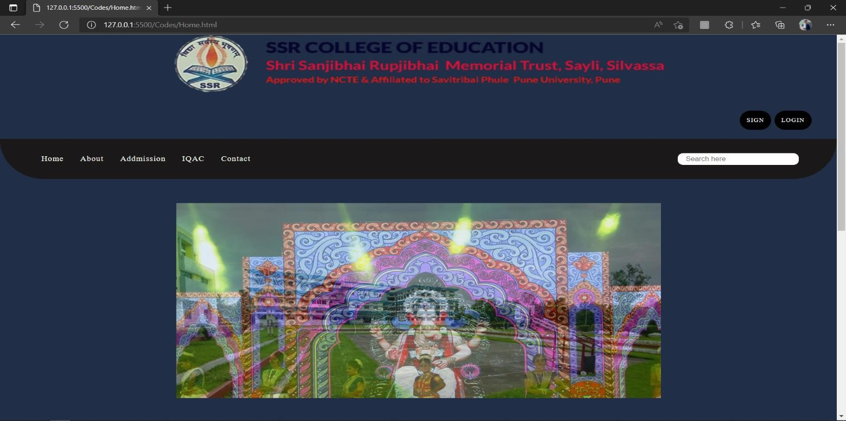

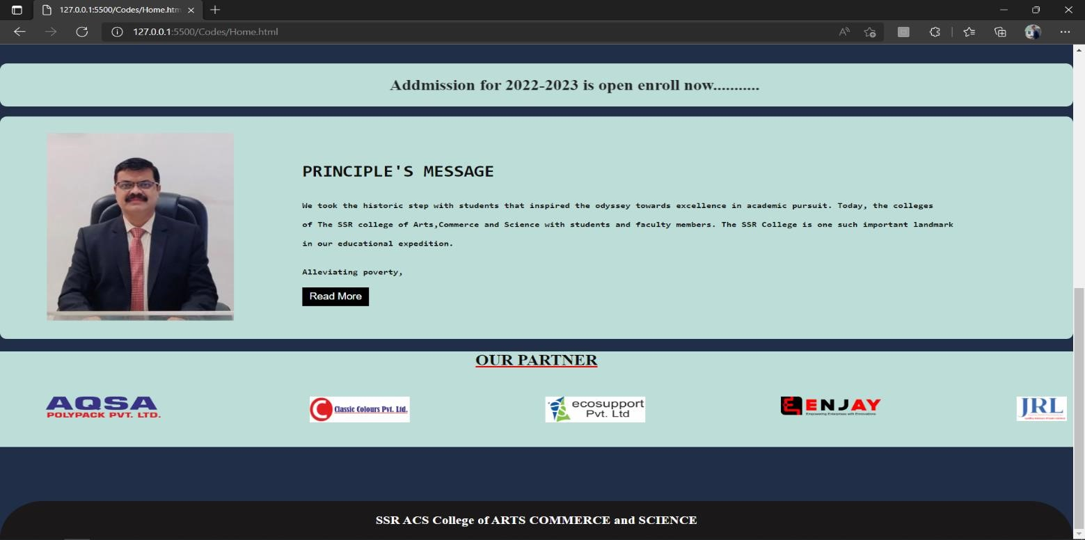

###### About Page:-

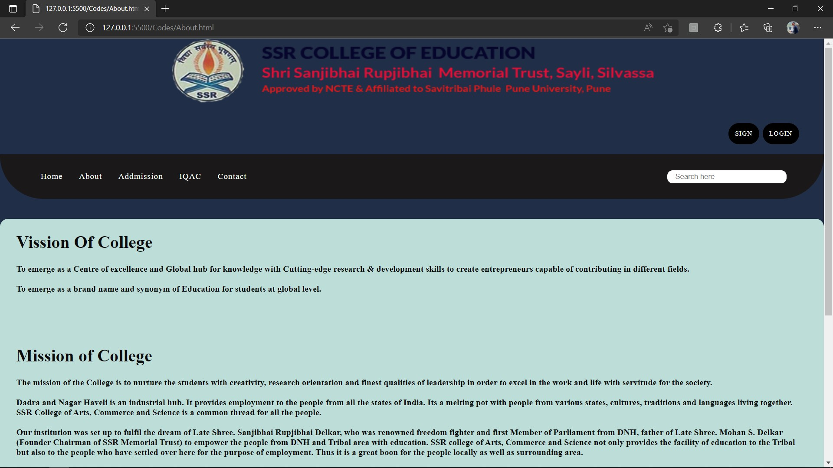

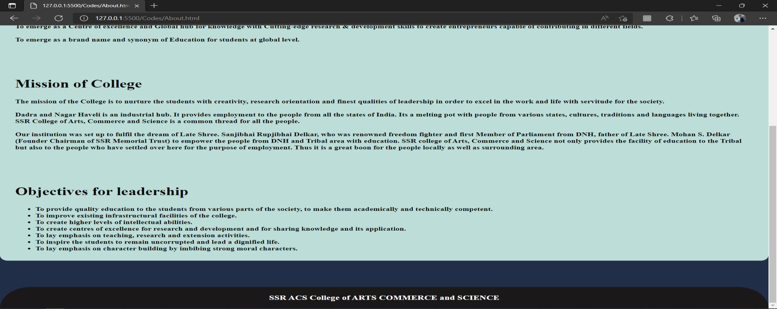

###### Addmission Page:-

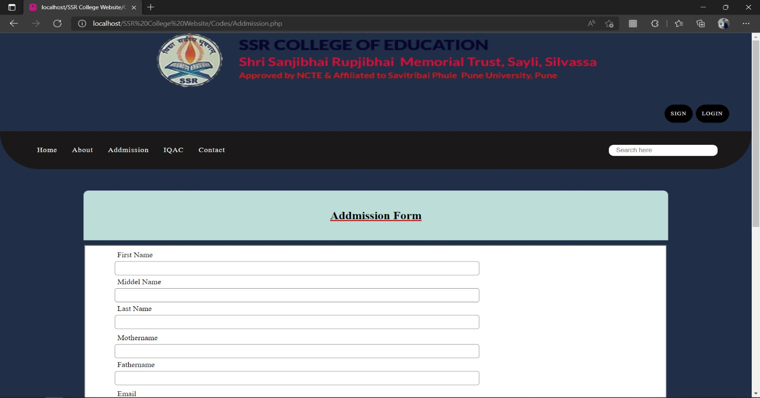

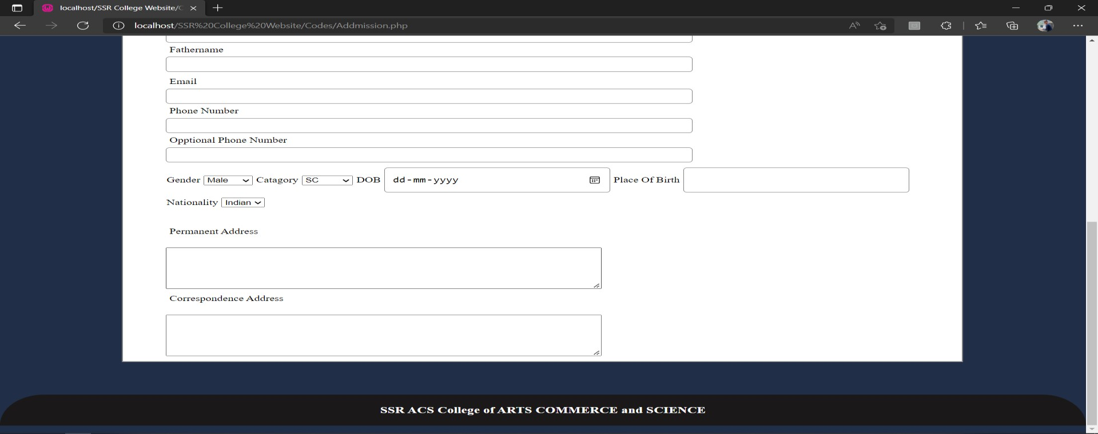

###### IQAC Page:-

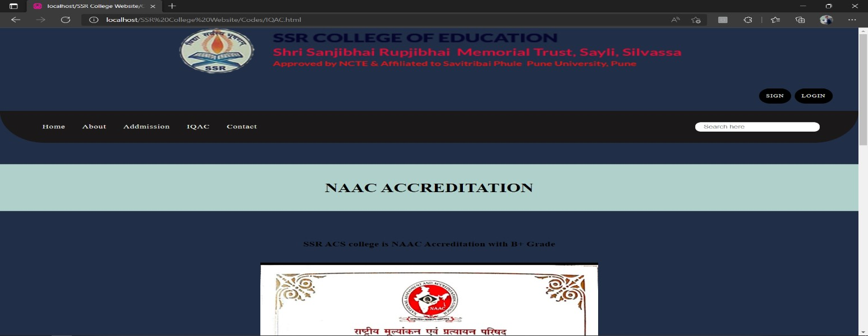

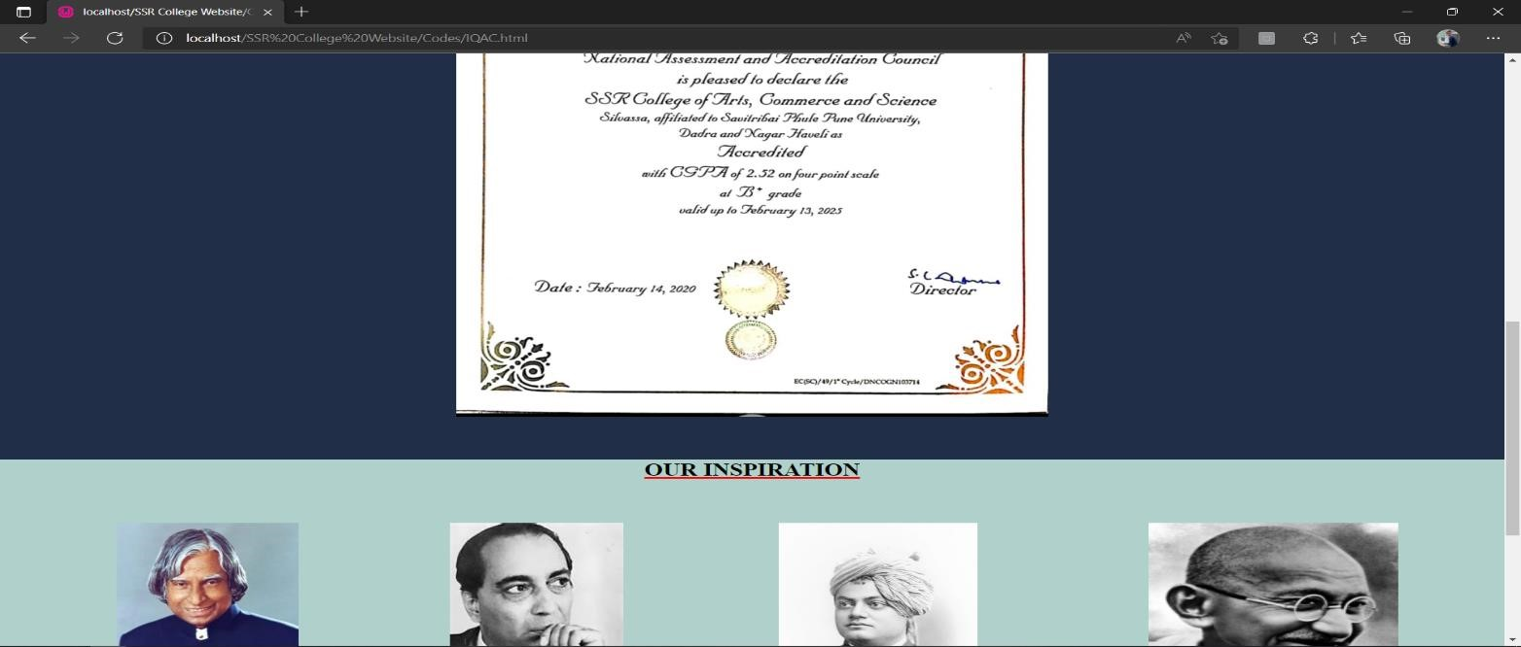

###### Contact Page:-

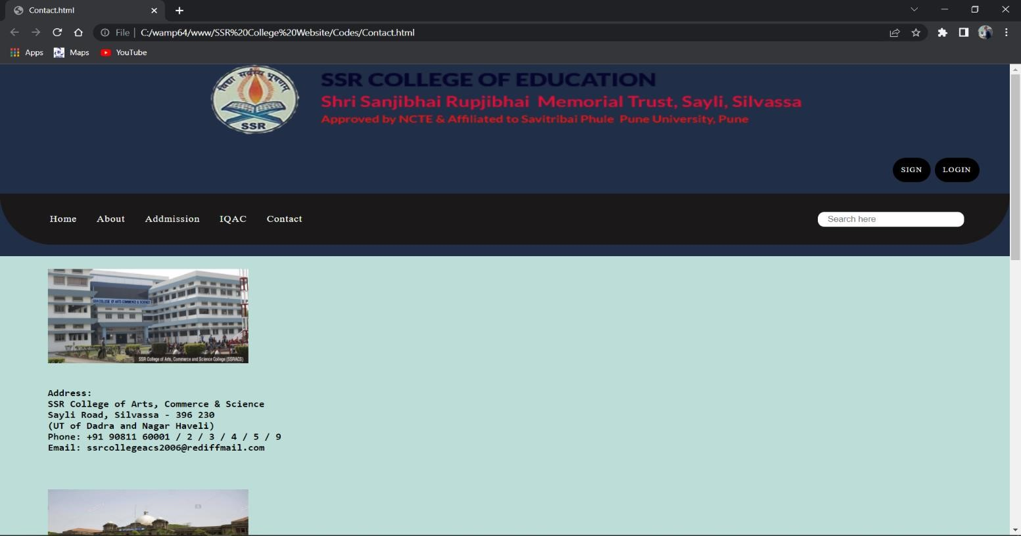

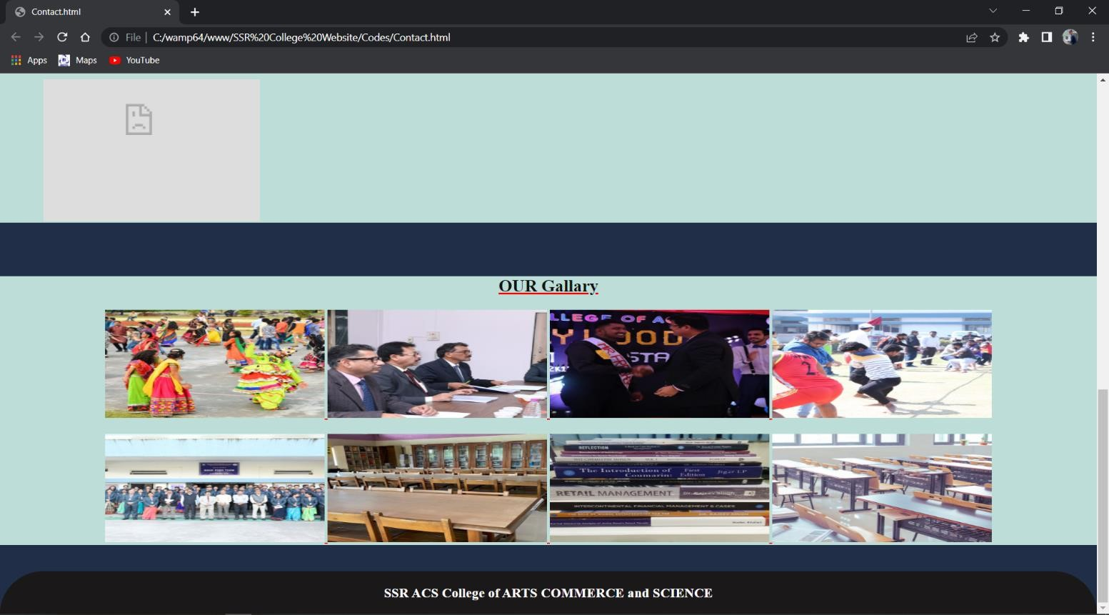

###### Register user:-

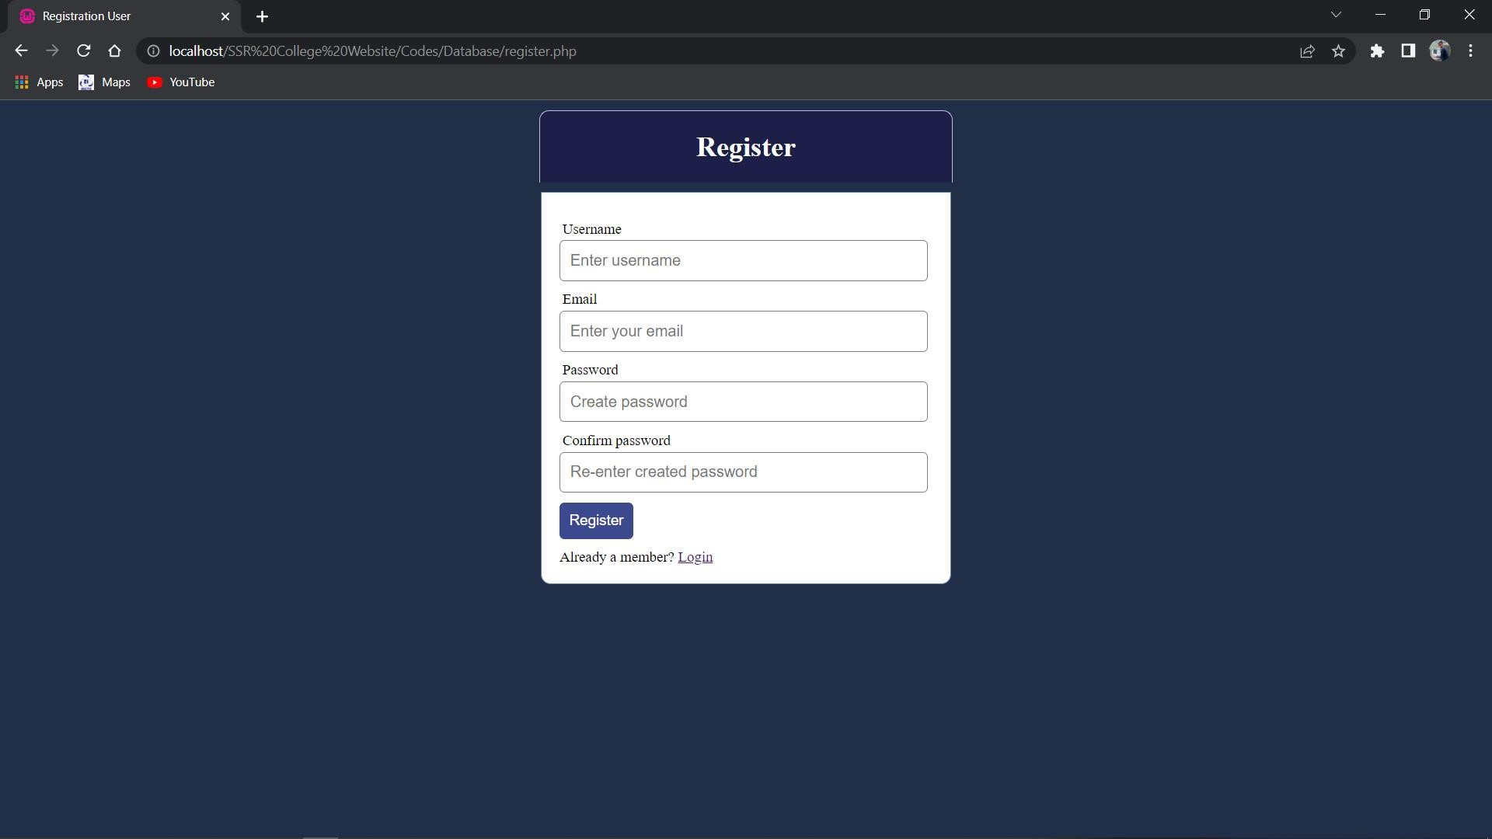

###### Login User:-

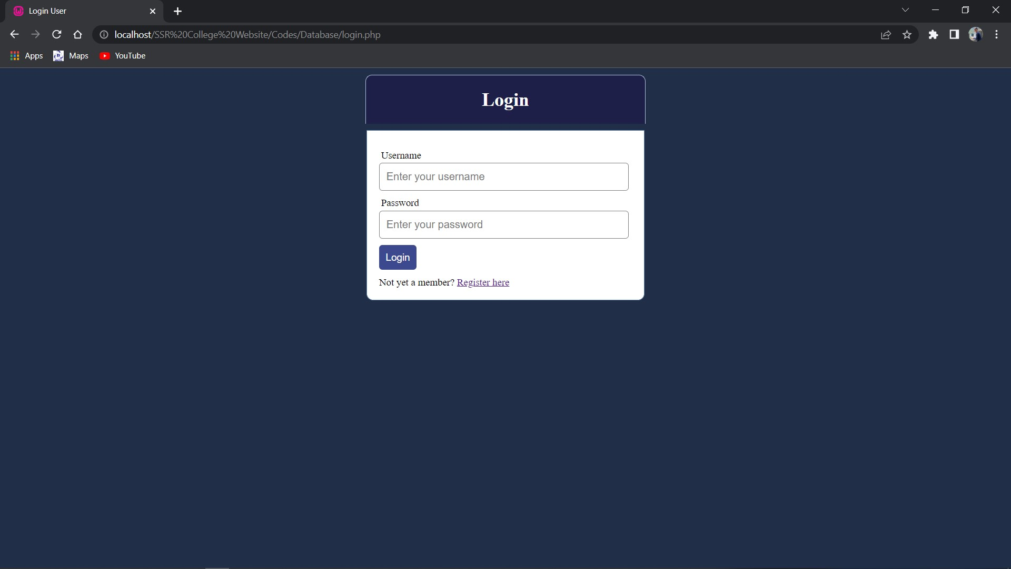

##### Welcome Page:-

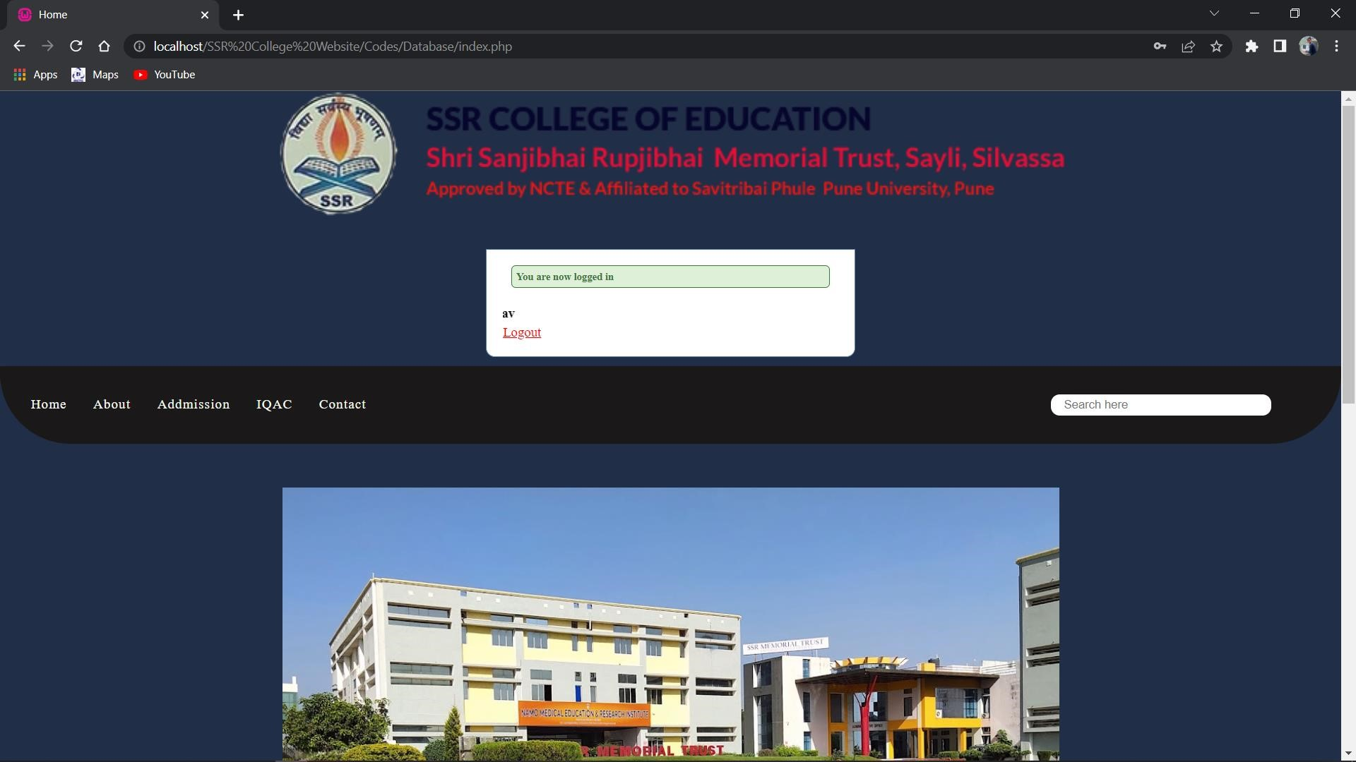

#### 

#### 7. FUTURE ENHANCEMENT

The system is designed in such a way that addition of new modules can be done in a very simple and efficient manner. The future holds a lot to offer to the development and refinement of this project. As proper documentation exists the whole system flow is traceable. Some likely enhancements could be added in the future to enhance the capability of this system. We may conclude that this software created will definitely find a good market in the SSR College Management System to its maximum extend.

#### 

#### 8. BIBLIOGRAPHY

[www.Google.com](http://www.google.com/)

[www.youtube.com](http://www.youtube.com/)

[www.Stackoverflow.com](http://www.stackoverflow.com/)

# THANKYOU